对应题目：
6.Quoit Design
7.Elevator
8.Number Sequence
9.Uniform Generator
10.Max Sum

6.
程序代码：#include <iostream>
#include <cmath>
#include <iomanip>
#include <vector>

using namespace std;

double calculateDistance(pair<double, double> p1, pair<double, double> p2) {
double dx = p1.first - p2.first;
double dy = p1.second - p2.second;
return sqrt(dx * dx + dy * dy);
}

double findMaxRadius(vector<pair<double, double>>& toys) {
double maxRadius = 0.0;

for (size_t i = 0; i < toys.size(); ++i) {
for (size_t j = i + 1; j < toys.size(); ++j) {
double distance = calculateDistance(toys[i], toys[j]);
maxRadius = max(maxRadius, distance / 2);
}
}

return maxRadius;
}

int main() {
int N;
while (cin >> N && N != 0) {
vector<pair<double, double>> toys(N);

for (int i = 0; i < N; ++i) {
cin >> toys[i].first >> toys[i].second;
}

double maxRadius = findMaxRadius(toys);

cout << fixed << setprecision(2) << maxRadius << endl;
}

return 0;
}
运行结果：
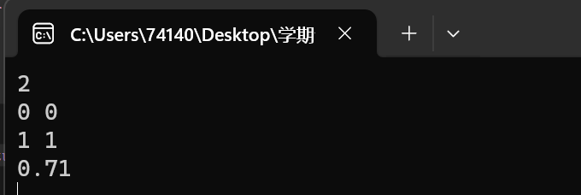

7.
程序代码：
#include <iostream>

using namespace std;

int calculateTime(int currentFloor, int nextFloor) {
int time = 0;

if (nextFloor > currentFloor) {
time += (nextFloor - currentFloor) * 6;
}
else {
time += (currentFloor - nextFloor) * 4;
}

// Add 5 seconds for stopping at the floor
time += 5;

return time;
}

int main() {
int N;

while (cin >> N && N != 0) {
int total_time = 0;
int current_floor = 0;

for (int i = 0; i < N; ++i) {
int next_floor;
cin >> next_floor;

total_time += calculateTime(current_floor, next_floor);
current_floor = next_floor;
}

cout << total_time << endl;
}

return 0;
}
运行结果：
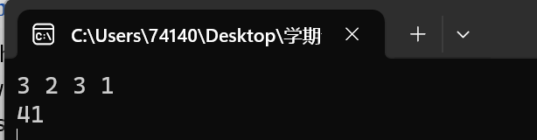

8.
程序代码：
#include <iostream>

using namespace std;

int calculateF(int A, int B, int n) {
if (n == 1 || n == 2) {
return 1;
}

int f_n_minus_1 = 1;
int f_n_minus_2 = 1;
int f_n;

for (int i = 3; i <= n; ++i) {
f_n = (A * f_n_minus_1 + B * f_n_minus_2) % 7;
f_n_minus_2 = f_n_minus_1;
f_n_minus_1 = f_n;
}

return f_n;
}

int main() {
int A, B, n;

while (cin >> A >> B >> n && !(A == 0 && B == 0 && n == 0)) {
int result = calculateF(A, B, n);
cout << result << endl;
}

return 0;
}
运行结果：
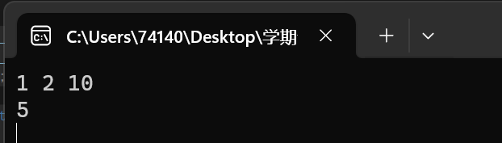

9.
程序代码：
#include <iostream>
#include <vector>
#include <tuple> // Add this line
using namespace std;

tuple<int, int, int> max_subsequence_sum(const vector<int>& nums) {
int max_sum = INT_MIN;
int current_sum = 0;
int start_position = 1;
int end_position = 1;
int current_start = 1;

for (int i = 0; i < nums.size(); ++i) {
current_sum += nums[i];

if (current_sum > max_sum) {
max_sum = current_sum;
start_position = current_start;
end_position = i + 1;
}

if (current_sum < 0) {
current_sum = 0;
current_start = i + 2;
}
}

return make_tuple(max_sum, start_position, end_position);
}

int main() {
int t;
cin >> t;

for (int case_num = 1; case_num <= t+1; ++case_num) {
int n;
cin >> n;
vector<int> sequence(n);
for (int i = 0; i < n; ++i) {
cin >> sequence[i];
}

auto result = max_subsequence_sum(sequence);
int max_sum, start_position, end_position;
tie(max_sum, start_position, end_position) = result;

cout << "Case " << case_num << ":" << max_sum << " " << start_position << " " << end_position << endl;

if (case_num <= t+1) {
cout << endl; // Output a blank line between two cases
}
}
getchar();
return 0;
}
运行结果：
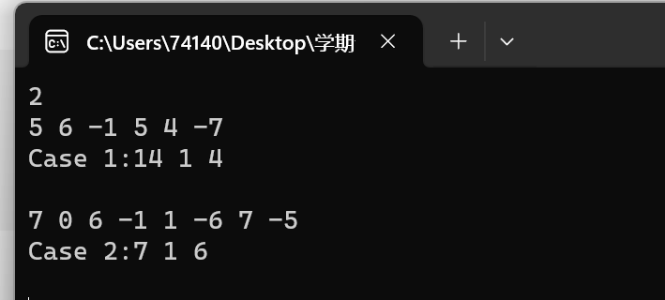
10．
程序代码：#include <iostream>
#include <algorithm>
#include <iomanip> // Add this line
#include <vector>

using namespace std;

int gcd(int a, int b) {
if (b == 0) {
return a;
}
return gcd(b, a % b);
}

int main() {
int STEP, MOD;

while (cin >> STEP >> MOD) {
int greatestCommonDivisor = gcd(STEP, MOD);

cout << right << setw(10) << STEP << right << setw(10) << MOD;

if (greatestCommonDivisor == 1) {
cout << " Good Choice" << endl;
}
else {
cout << " Bad Choice" << endl;
}

cout << endl;
}

return 0;
}

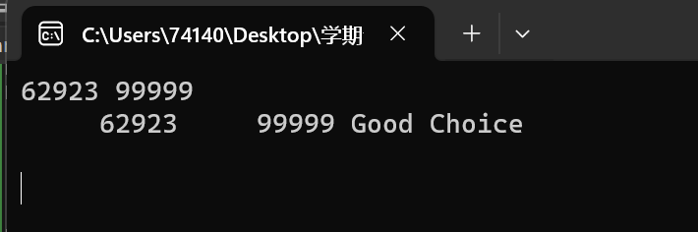

实验一成绩：____________ 教师签名：_______________

